Name :-Kunal R Agarwal
SRN No:-201700110
Roll No:-18
Topic:-Case Study on Genetics Algorithm
********************************************************************************
Electricity estimation using genetic algorithm of Turkey

1.Introduction

With a young and growing population, low per capita electricity consumption, rapid urbanization, and strong economic growth, Turkey was/is one of the fastest growing power markets in the world, for nearly two decades . Turkey’s energy consumption and imports were experiencing rapid growth as was the Turkish economy. Due to the small increase in energy production, and to rapid demand, growth energy imports had increased rapidly and were expected to continue to increase in further years. Net energy imports grew 28.5 million tons of oil equivalent (mtoe) in 1990 to 54.4 mtoe in 2000, and were expected to reach 228.2 mtoe in 2020. Net energy import, which met 54% in 1990 and 67% in 2000 of the total primary energy supply (TPES), will increase to 76% in 2020 . Turkey’s electricity demand has been growing very rapidly. It had increased from 56.8 TWh in 1990 to 118.5 TWh in 2000, with an annual average growth rate of 8.1%. The growth in electricity generation in
recent years was below growth in electricity demand. Therefore, Turkey has become a net importer of electricity since 1997. The electricity demand of Turkey is expected to increase 555.7 TWh in 2020. The electricity installed capacity had reached from 16.3 GW in 1990 to 26.1 GW in 1999, and is projected to increase to 104.9 GW in 2020. With the increase in electricity demand per capita, electricity consumption was realized to be 1013 kWh in 1990 and will increase to 6794 kWh in 2020 . The share of industrial sector energy consumption in total final consumption had decreased from 62% in 1990 to 48% in 2001 . On the other hand, the electricity demand increased from 29,211 to 46,989 GWh. Installed hydroelectric power plants provided approximately 32% of the total electrical power during 1970. In contrast, during the same year, 68% of installed electrical power came from thermal power plants. In 2000, electricity production of hydroelectric had increased to 75%. Total installed power increased 12 times from 1970 to 2000. After 1993, there was no recognizable change for the hydraulic power installation. Thermal power plant installation showed a rapid increase after 1997 due to the installation of natural gas power plants . The estimation of electric energy demand, based on the socio-economic indicators, may be estimated with various forms of mathematical expressions. The equations may be linear or non-linear forms. The non-linear forms of the equations can better estimate the future electricity demand of Turkey due to the fluctuations of socio-economic indicators
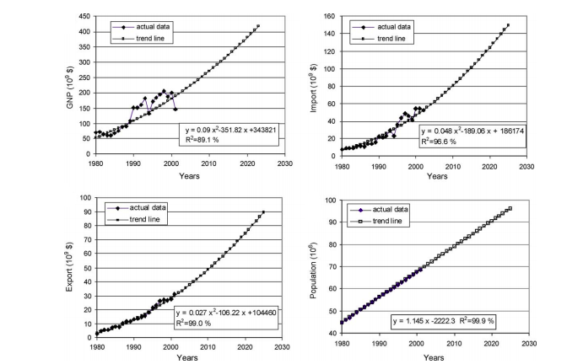

GAs, as powerful and broadly applicable stochastic search and optimization techniques, are the most widely known types of evolutionary computation methods today. Similar to the natural evolution process, where a population of a given species adapts to a natural habitat, a population of designs is created and then allowed to evolve in order to adapt to the design environment under consideration. They are search and optimization techniques motivated by natural principles. GAs have been successfully applied to a wide range of problems from optimization problems in engineering energy design in buildings . GAs also provide a robust and powerful optimization technique for multi-modal nonlinear design problems. Estimation of the future energy is very important due to the make correct investments. Many researches have recently been carried out to estimate the energy demand using GA approach. The main of this study is to estimate the Turkish electricity demand and is to show if the GA approach is a useful tool for this application. Therefore, various forms of the mathematical expressions are used, while genetic algorithm electricity demand model (GAELDM) and genetic algorithm industrial electricity demand model (GAINELDM) are proposed to estimate total electricity and industrial electricity demand of Turkey. The GAELDM/GAINELDM are used to estimate the Turkish total electric energy utilization and industrial electricity demand based on gross national product (GNP), population, import and export figures, which are selected important indicators that show the socio-economic chances of Turkey.

2.Genetics Algorithm

The GA is a global optimization method based on the principle of survival of the fittest; Darwin’s hypothesis of evolution. The basic principles of the GA are attributed to Holland [13] and have been adapted for a large number of applications in different areas. GA is similar to the natural evolution process where a population of a given species adapts to a natural environment, a population of designs is created and then allowed to evolve in order to adapt to the design environment under consideration. GAs encode a possible solution to a specific problem on simple chromosome string like data structure and apply specified operators to these structures so as to preserve important information, and to produce a new set of population with the purpose of generating strings which map to high function values. The basic operations of GA, a selection, a crossover of genetic information between reproducing parents and a mutation of genetic information affect the binary strings characteristic in natural evolution. A description of the GA is as follows. In biological population, genetic information is usually stored in the form of binary strings. The basic processes, which affect the binary strings makeup in natural evolution, are a selection, a crossover of genetic information between reproducing parents and a mutation operation. In Holland’s work, genetic operators manipulated the bit string representations of possible solutions to considered problem in order to improve those solutions. Consider a function, Fi, which is to be minimized between limits Xmax and Xmin on the design variable X. The lower and upper bound values of the associate design variables appointed into the corresponding binary number of XminZ 0 0 0 0 0 0 0 0 and XmaxZ 1111 1 1 1 1, while assuming that there is an 8-digit binary number. The values between the lower and upper bounds are scaled and converted to the corresponding binary strings using several scaling methods. For instance, integer values of 1, 2, 3 and 4 can be represented as 00, 01, 10 and 11 using 2 bit string representations, respectively. Each string represents one design, and multiple strings constitute the whole set of designs. In multiple strings, each binary string of design parameters is stacked head to tail to form a single chromosome-like string to represent a population of designs such as, Weighting variables w1 w2 wi . Binary string representation 101.01 111.001 001.0111 . A sequence of such strings can be introduced to construct a population of designs, with each design having a corresponding fitness value, which is the sum of squared error (SSE). The basic operators of GA are performed based on the fitness function evaluation. The basic operators of genetic search are selection, crossover, and mutation are summarized for completeness. Selection. Selection operator biases the search process in favor of the more fit members based on their fitness value, Fi. The fitness value of the ith member in the population can participate in this operation based on its probability. The probability of the ith member in population is computed as follows.

where n is the population size. In the selection operation, the more fit members of the population can participate more than once, while less fit members may completely be suppressed that lead to an increase in average fitness.
Crossover. The crossover operation allows for an exchange of design characteristics among the mating members. The operation is executed by selecting two mating parents, randomly choosing two sites on each of the chromosomal strings, and swapping strings between the sites among the pair. An illustration of the crossover operation is as follows:

Parent 1 = 1010 1 010 1 1
Parent 2 = 1001 0 001 1 1
Child 1 = 1010 0 001 1 1
Child 2 = 1001 1 010 1 1

The crossover operation is carried out with a probability pc. Typical probability values range from 0.2 to 0.8. Mutation. Mutation operation is another essential operation in GA process, and is one safeguards the process from a premature loss of valuable genetic information in the population during selection and crossover operation. Working with finite sized population, there is a risk of premature loss of some genetic information from the population. The mutation operator is invoked with a low probability (pm) at a randomly selected site on chromosomal string of the randomly chosen design. The operation consists of a switching of a 0–1 or vise versa. A realization of the mutation operation is as follows:

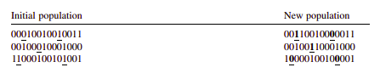

The genetic processes continue to obtain new design with improved fitness until no applicable change in fitness is observed, or a specified number of function evaluations have been performed.
The fitness function. The GA works according to selection rules as defined by the laws of evolutionary genetics. The model seeks the ‘fittest’ model to the observed values. In the energy demand estimation, it is the model whose parameters are put into the source (i.e. GNP, population, import and export) model, produce energy demand, to best match the measured demand. The fitness function, Fi(x), takes the following form:

where Eactual and Epredicted are the actual and predicted energy demand, respectively, m is the number of observations, and si is the weighting factor.
The GA works with these operations that are performed based on fitness evaluation. The fitness indicates the goodness of design, and therefore, the objective function is a logical choice for the fitness measure. The GAELDM/GAINELDM searches the most fitted members by minimizing the error. The model captures the best model by randomly selecting the set of weighting parameters and evolves them to create the best model under minimized error. The same forms of equations have been used for the estimation of both total and industrial electricity demand. The quadratic forms of GAELDM/GAINELDM can be written as follows:

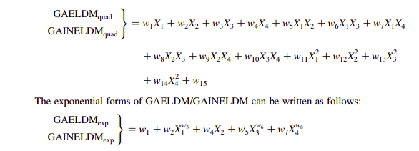
where X1, X2, X3 and X4 are the GNP, population, import, and export figures, respectively, and wi indicates the corresponding weighting factors.

3. The GAELDM/GAINELDM application and validation

The data were collected from different sources. The GNP and total final energy consumption data are collected from the Central Bank of Turkey and World Energy Council-Turkish National Committee (WEC-TNC) . Turkey’s general import and export figures are obtained from National Statistics , while the future planning of energy demand is taken from WEC-TNC and the Turkish Ministry of Energy and Natural Resources (MENR) . The results obtained from GAELDM/GAINELDM are compared and validated with the MENR projections. The GAELDM/GAINELDM either in quadratic or in exponential forms are performed for total and industrial electricity demand using the following user-specified parameters.
Population size (n): 60
Generation number (t): 500
Number of decision variables (k): 15
Probability of crossover (pc): 0.5
Probability of mutation (pm): 0.02
After the GAELDM/GAINELDM have applied to the total and industrial electricity demand problem, the following parameter values are obtained, which result in the minimum SSE between observed energy demand and estimated data. In the quadratic form of the GAELDM/GAINELDM, coefficients obtained are given below. For total electricity demand
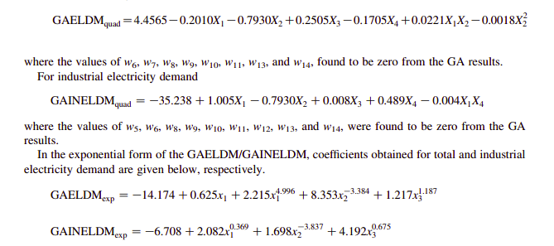
The convergence of the algorithms can be obtained in detail elsewhere. During the GAELDM/GAINELDM modeling process, each form of the model is validated using the available data partly for use in estimating the weighting factors and partly for the testing purposes. First, 16 years observed data from 1980 to 1995 is used for estimating the weighting factors and the 6 years data from 1996 to 2001 is then used for testing. The testing procedure is performed to obtain the minimum relative error between the observed and estimated values in the period of 1996–2001. The relative errors between observed and estimated values are reported in Tables 1a and 1b, respectively. The average relative errors are: 3.75% for the GAELDMexp, 2.99% for GAELDMquad and 20% for the MENR projection . The average relative errors for industrial sector are: 3.35% for the GAINELDMexp, 1.42% for the GAINELDMquad and 54.3% for the MENR projection.

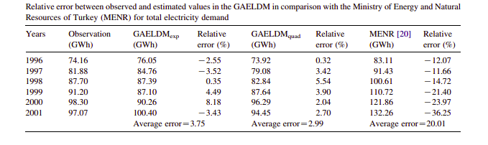
The exponential and quadratic forms of the GAELDM/GAINELDM models are resulted in the lower relative errors when they are compared with the MENR projections. As can be seen in Table 1a, the maximum estimation error forecasted with the MENR [20] method is about 36% for total electricity estimation. For the industrial sector (GAINELDM), maximum 8% estimation error is obtained while the maximum MENR projection error is about 80%.

4. Future projections for the total and industrial sector electricity demand

The future projections for the electricity demand estimation either in total or industry are carried out in the following way. For each socio-economic indicator, the polynomial trend lines are fitted to the observed data with highest R2 vales. Then, using the trend line (i.e. time series approach) expressions, the forecasting for each indicator are made first, then the electricity demand are forecasted using the GAINELDM for industry and GAELDM for total electricity.

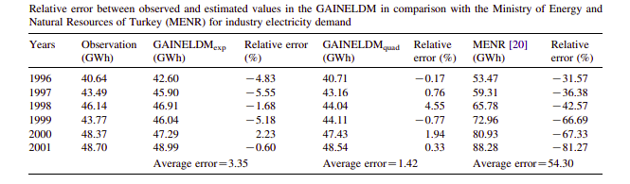

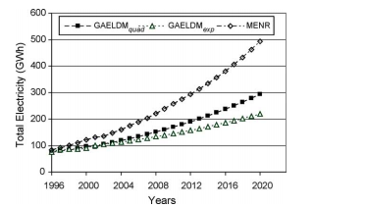

Fig-1 Future projections of total electricity demand of Turkey.

of Turkey is overestimated by the MENR. This could be due to the economic crises, which hit Turkey two times in the 1990s. The quadratic form of the GAELDM is slightly better than the exponential form of the model due to the inclusion of the relations between the estimated indicators and the relative errors are checked for the validation period. This can also be the model used itself. The two forms of the GAELDM model fitted to current data resulted in about the same estimation values for Turkey’s future industrial electricity demand, but the MENR projections for that period are high when they are compared to the observed data for the validation period. As can be seen in Fig-2, the differences between the MENR and the two forms of the GAELDM approach are huge. This could be the unexpected event like socio-economic changes or economic cries in Turkey within the past 10 years.

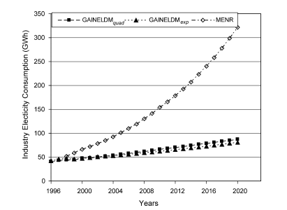

Fig-3. Industrial electricity demand of Turkey.

5. Conclusions

In this study, the total and industrial sector electricity demands of Turkey are studied based on GNP, population, import and export figures. The parameters of the GAELDM and GAINELDM developed either in quadratic or exponential forms were obtained using the observed data. The GAELDM and GAINELDM were validated for the period of 1996–2001 with observed and estimated data. The various forms of the modeling approach were performed, while the results obtained were compared to observation and the MENR projections. The following main conclusions may be drawn from the results of the present study:
(a) The GAELDM and GAINELDM in both forms can be used as an alternative solution and an estimation of techniques to total and industrial electricity demand of Turkey. It can also be used for estimating the energy demand in the future by optimizing the parameter values using available data. Other advantage of the GAELDM and GAINELDM model is that any type of mathematical representation can be solved with the GA approach provided that appropriately represents the objective (fitness) function.

(b) The quadratic form of the GAELDM and GAINELDM models provided slightly better fit solution to the observed data. Hence, this form can be selected for Turkey’s future energy projections.

(c) The estimation of total electric energy demand of Turkey in both forms of the GAELDM and GAINELDM is less when the results are compared to the MENR, but the relative error in the testing period is lower than the MENR in the GAELDM and the GAINELDM method.

(d) The electricity projection of the MENR during the period of 1996–2001 is overestimated for both total and industrial electricity demand as 36 and 81%, respectively. This overestimation may be for two reasons:
(i) The model that the MENR using is not suitable for Turkey, and (
ii) The electricity demand may be shown higher than what the country needs in order to establish electric power plants to use excess amount of natural gas.

(e) This study deals with the estimation of electricity demand in Turkey using GA approach. The results are compared with the MENR projections.

However, an estimation of electricity demand can also be investigated with Fuzzy Logic, Neural networks or other methods. The results of the different methods could be compared with the GA method to see the performance of methods.

References

Electricity estimation using genetic algorithm approach: a case study of Turkey
https://doi.org/10.1016/j.energy.2004.08.008

